**QUOTATION**

Quotation no: Sheetal 215

Date 17/09/2022

**To**

**Mr. Sheetal,**

**Goa**

Dear Sir,

Kindly check the quotation as per your requirement.

|  |  |  |  |  |
| --- | --- | --- | --- | --- |
| **SR NO** | **ITEM DESCRIPTION** | **QTY** | **PRICE** | **AMOUNT** |
| 1* | Honeywell 2MP IP Fixed Lens Bullet Camera Cam, Built in Mic, 4MM / 2.8MM Lens, POE, IP67, VCA-Tripwire/Perimeter | 39 | 5490 | 214110 |
| 2* | Honeywell NVR Professional Series 40 CH | 1 | 52900 | 52900 |
| 3 | WD Purple Surveillance Hard Disk 2 TB | 2 | 4980 | 9960 |
| 4 | 8 + 2 Port POE Giga Switch D link or Secure Eye or Similar | 7 | 8900 | 62300 |
| 5 | Enclosure with mounting | 39 | 110 | 4290 |
| 6 | RJ 45 Connector With Crimping etc complete | 85 | 160 | 13600 |
| 7 | Dlink, CP Plus Or Similar Network Rack 4 U | 1 | 3990 | 3990 |
| 8 | Dlink, CP Plus Or Similar Network Rack 2 U | 6 | 2500 | 15000 |
| 9 | Supply and laying of cat 6 cables through PVC pipe / casing capping to be charged as actuals @ 95/- per mtr + GST | 550 | 95 | 52250 |
| 10 | HDMI cable (3mtrs) | 1 | 500 | 500 |
| 11 | Spike Board | 1 | 600 | 600 |
| 12 | INSTALLATION TESTING COMMISSIONING | 1 | 15000 | 15000 |
| **TOTAL** | | | | **444500** |
| **GST 9%** | | | | **40005** |
| **GST 9%** | | | | **40005** |
| **Grand Total** | | | | **524510** |
|  |  |  |  |  |
| If required extra Supply and laying of cat 6 cables through PVC pipe / casing capping to be charged @ 95/- per mtr + GST | | | | |
|  |  |  |  |  |
| **If required:-** | |  |  |  |
| **1)Display 19'' @7900 + GST** | |  |  |  |
| **2) Patch panel 12 port loaded @ 1500/- + GST** | |  |  |  |
|  |  |  |  |  |
| **In lieu of** |  |  |  |  |
| **1) Honeywell 4 MP Motorized Bullet Varifocal Motorized Lens 2.8-12mm, IH+265/ H.265/H.264 ,120dB WDR, Smart IR Range Up to 80 m Built-in Mic,SD Card Slot, Reset Button, ,Full Metal Housing,IP 67,IK10 @ 18690/- + GST** | | | | |
|
| **2) Honeywell NVR Professional Series 80 CH @ 129800/- + GST** | | |  |  |

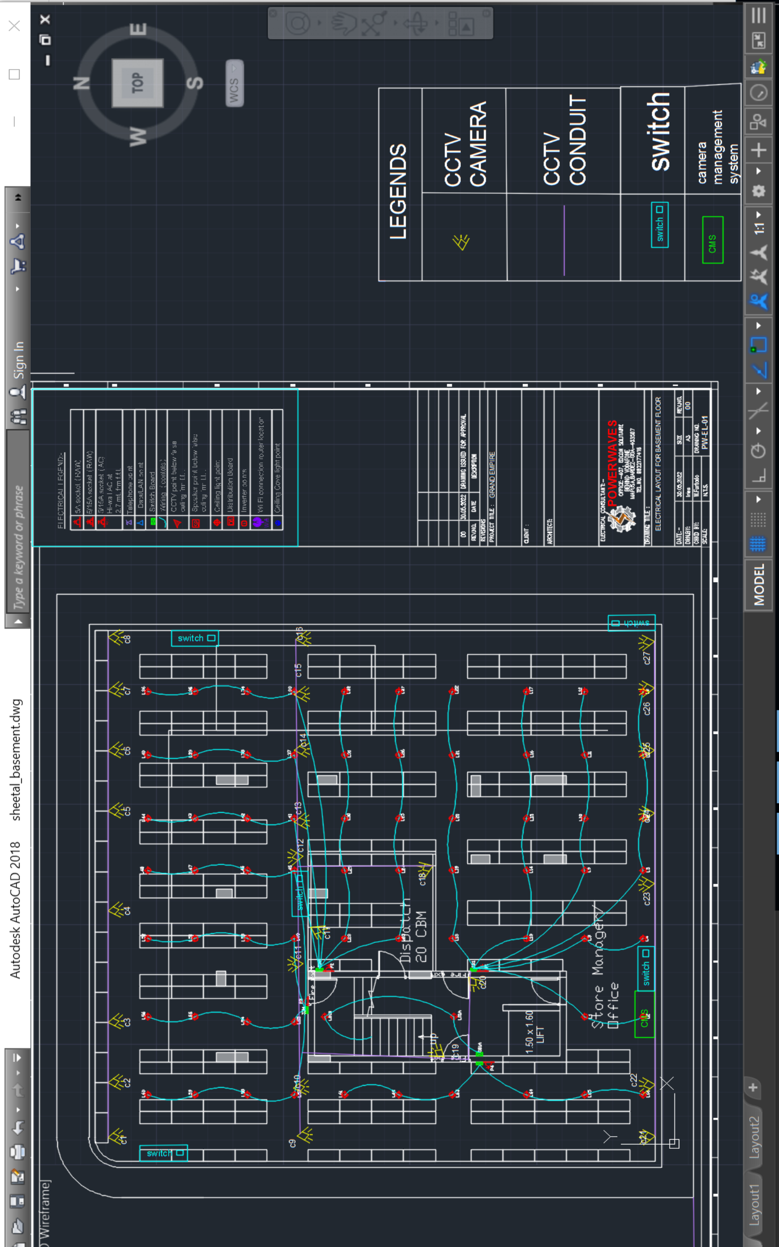

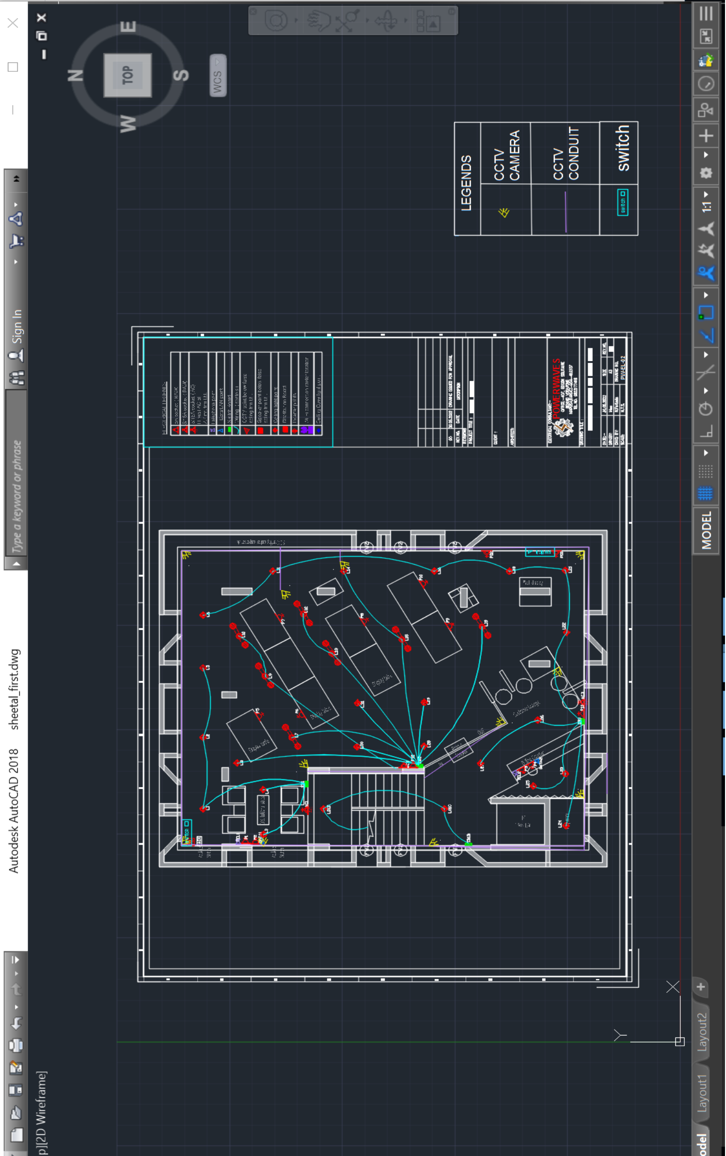

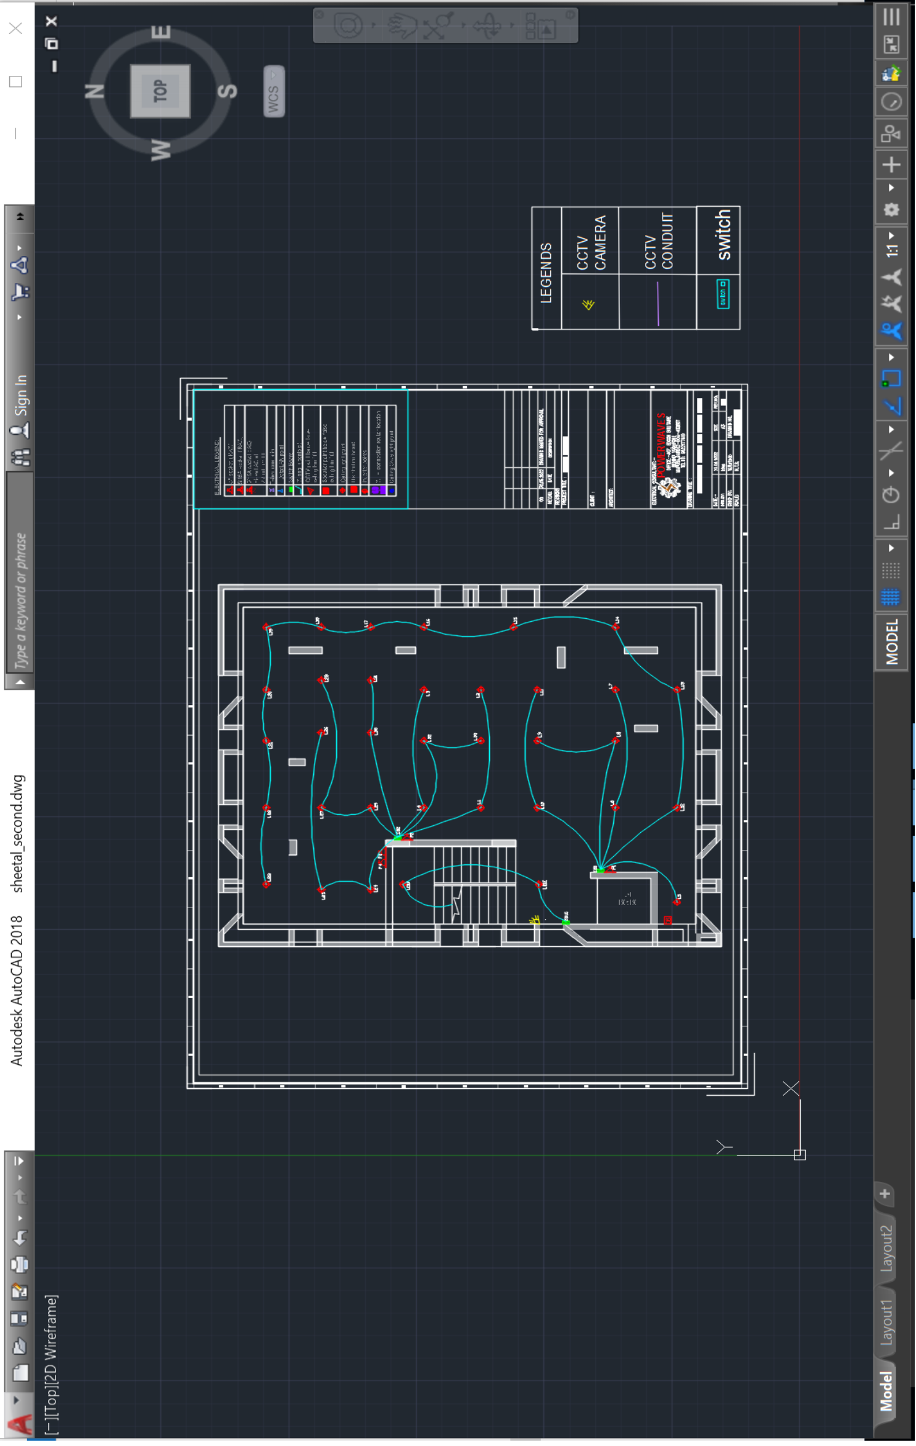

**Client scope:**

Scaffolding wherever required to be provided.

Electrification wherever necessary to be provided.

Fabrication like poles etc. to be provided.

Fabricated poles if required to be provided.

Civil work if required.

**Payment Terms**

100 % Advance

**Company’s Bank Details**

**Bank Name:** Central Bank of India

**Account Number:** 3167002097

**Branch & IFS Code:** Panaji & CBIN0280713

**Terms & conditions apply**.

Quotation valid for 10 days only.

Any extra item if required to be charged as actual.

Warranty as per manufacturer not valid in case of surges, fluctuation, lightening etc.to be claimed directly with the

manufacturer without involving JP TECHATRONICS.

Solution done as per recommendation and request by client hence, JP TECHATRONICS or its employees should not be held responsible for any kind of malfunctioning of the system for any reasons.

Services like data backup, searching footage, port forwarding etc. to be charged as actuals.

Service calls post installation to be charged as actuals.